LAB EXPERIMENTS

NAME:P.GURU DHANUNJAY
REG.NO:192321122
SUB.CODE:ITA0435

1.Create numeric, character, and logical vectors and display type and content.
Program:
num_vec <- c(10, 20, 30, 40)
print(num_vec)
print(typeof(num_vec))
char_vec <- c("AI", "ML", "NLP")
print(char_vec)
print(typeof(char_vec))
log_vec <- c(TRUE, FALSE, TRUE)
print(log_vec)
print(typeof(log_vec))
OUTPUT:-
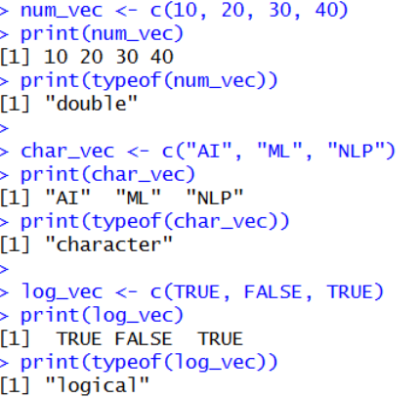

2.Create labelled matrices (5×4, 3×3, 2×2) filled by row/column.
Program:
m1 <- matrix(1:20, nrow=5, ncol=4, byrow=TRUE)
rownames(m1) <- paste("R",1:5,sep="")
colnames(m1) <- paste("C",1:4,sep="")
print(m1)
m2 <- matrix(1:9, nrow=3, ncol=3, byrow=FALSE)
rownames(m2) <- c("A","B","C")
colnames(m2) <- c("X","Y","Z")
print(m2)
m3 <- matrix(c(5,6,7,8), nrow=2, byrow=TRUE)
rownames(m3) <- c("Row1","Row2")
colnames(m3) <- c("Col1","Col2")
print(m3)
Output:-
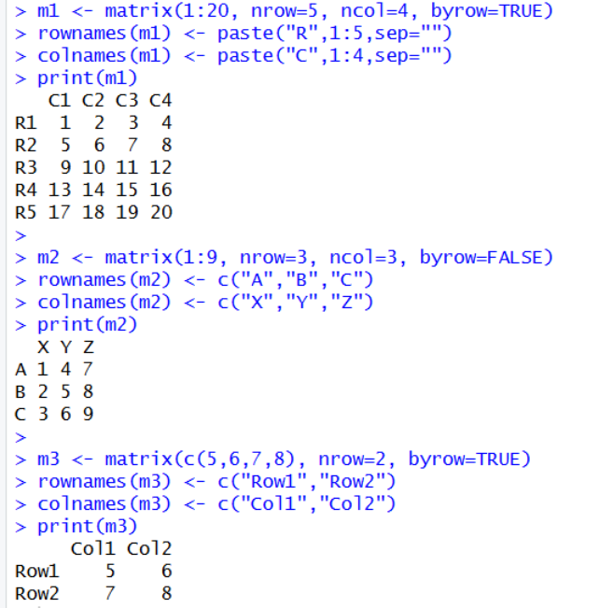

3.Write an R program to create and display a 3D array with specified rows, columns, and tables.
Program:
arr <- array(1:12, dim=c(2,3,2))
print(arr)
Output:-
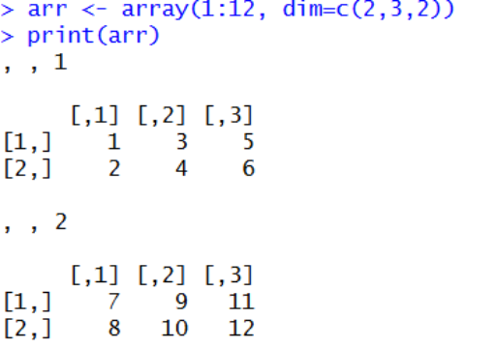
4.Create arrays from vectors with dimension names, print specific elements.
Program:
vec <- c(10,20,30,40,50,60)
arr2 <- array(vec,
dim=c(2,3),
dimnames=list(
Rows=c("R1","R2"),
Cols=c("C1","C2","C3")
))
print(arr2)
print(arr2["R2","C3"])

Output:-
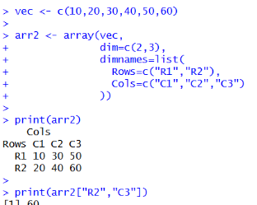
5. Create and manipulate factor variables (e.g., women’s dataset heights, random LETTERS sample).
Program:
data(women)
height_cat <- cut(women$height, breaks=3,
labels=c("Short","Medium","Tall"))
print(height_cat)
print(levels(height_cat))
set.seed(10)
letters_sample <- sample(LETTERS[1:5], 10, replace=TRUE)
letter_factor <- factor(letters_sample)
print(letter_factor)
print(levels(letter_factor))

Output:-
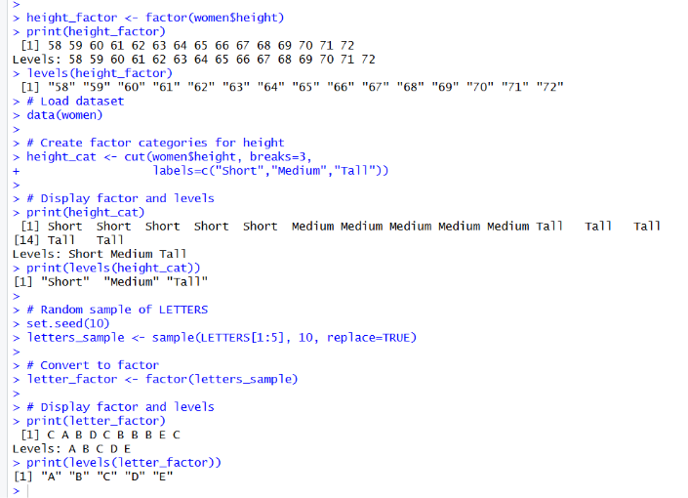
6. Create an R list containing vectors, matrices, and functions; display contents.
PROGRAM:
num_vec <- c(1,2,3)
mat <- matrix(1:4, nrow=2)
square <- function(x) { x^2 }
my_list <- list(Vector=num_vec, Matrix=mat, Function=square)
print(my_list)
my_list$Function(5) # calling function
OUTPUT:
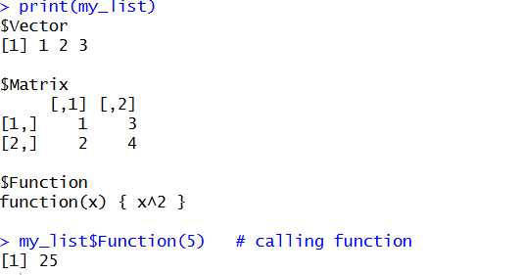
7. Write R programs for basic tasks: Factors of a number, generate a vector of 10 random integers between -50 and 50, print numbers 1–100 with FizzBuzz logic.
Program:
n <- 12
for(i in 1:n){
if(n %% i == 0)
print(i)
}
set.seed(1)
rand_vec <- sample(-50:50, 10)
print(rand_vec)
for(i in 1:100){
if(i %% 15 == 0) print("FizzBuzz")
else if(i %% 3 == 0) print("Fizz")
else if(i %% 5 == 0) print("Buzz")
else print(i)
}
OUTPUT:
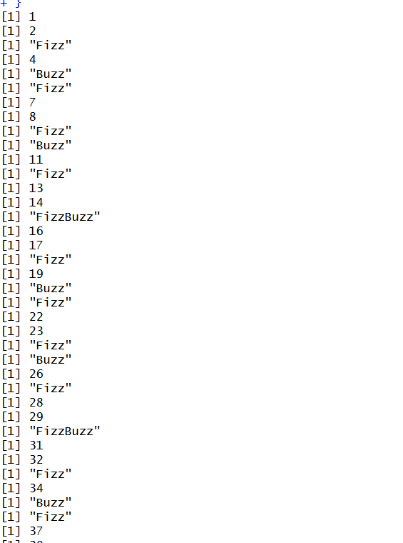
8. Generate random numbers from a normal distribution; count occurrences.
Program:
set.seed(1)
x <- rnorm(100, mean=0, sd=1)
summary(x)
table(cut(x, breaks=5)) # count in intervals
Output:
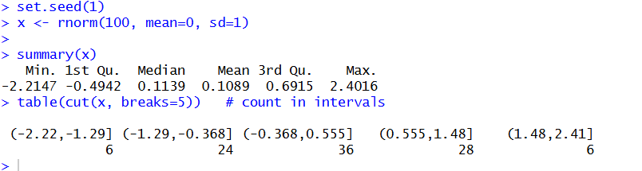

9. Create empty plots with specified axis limits.
PROGRAM:
plot(1, type="n", xlim=c(0,10), ylim=c(0,20),
xlab="X Axis", ylab="Y Axis",
main="Empty Plot")
OUTPUT:
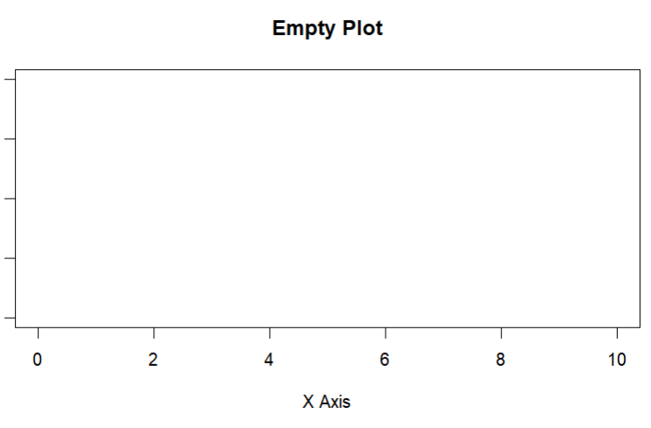
10. Create and explore a data frame exam_data with name, score, attempts, and qualify fields. Perform extract, add row/column, sort, save to file.
PROGRAM:
exam_data <- data.frame(
name=c("Sai","Ram","Priya","Anu"),
score=c(90,75,88,60),
attempts=c(1,2,1,3),
qualify=c("Yes","Yes","Yes","No")
)

print(exam_data)
# Extract
exam_data[exam_data$score>80,]
# Add row
new_row <- data.frame(name="Ravi",score=85,attempts=1,qualify="Yes")
exam_data <- rbind(exam_data,new_row)
# Add column
exam_data$grade <- ifelse(exam_data$score>=80,"A","B")
# Sort
exam_data <- exam_data[order(-exam_data$score),]
# Save
write.csv(exam_data,"exam_data.csv",row.names=FALSE)
OUTPUT:

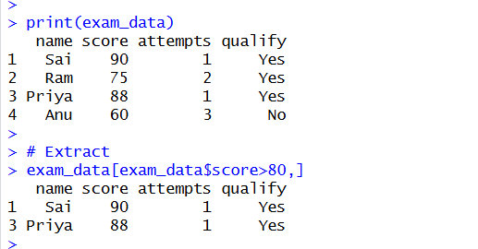
11. Write an R program to read a .csv file and display contents.
PROGRAM:
data <- read.csv("exam_data.csv")
print(data)
OUTPUT:
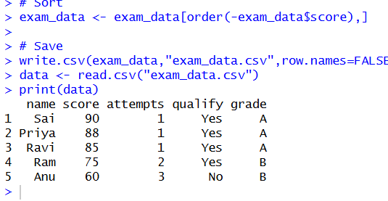
12. Perform data reshaping on airquality dataset: melt, cast, compute monthly averages for Ozone, Solar.R, Wind, and Temperature.
PROGRAM:
install.packages("dplyr")
library(dplyr)
data(airquality)
monthly_avg <- airquality %>%
group_by(Month) %>%
summarise(
Ozone = mean(Ozone, na.rm=TRUE),
Solar.R = mean(Solar.R, na.rm=TRUE),
Wind = mean(Wind, na.rm=TRUE),
Temp = mean(Temp, na.rm=TRUE)
)
print(monthly_avg)
OUTPUT:
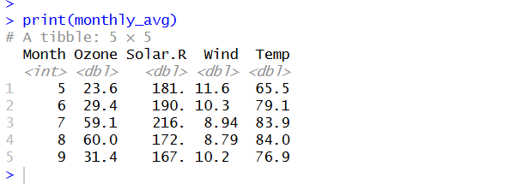
13.Combine multiple arrays row-wise.
PROGRAM:
data(iris)
dim(iris)
summary(iris)
apply(iris[,1:4],2,sd)
apply(iris[,1:4],2,quantile)
aggregate(.~Species,data=iris,mean)
iris$SepalCat <- cut(iris$Sepal.Length,breaks=3,labels=c("Low","Medium","High"))
table(iris$SepalCat,iris$Species)

OUTPUT:
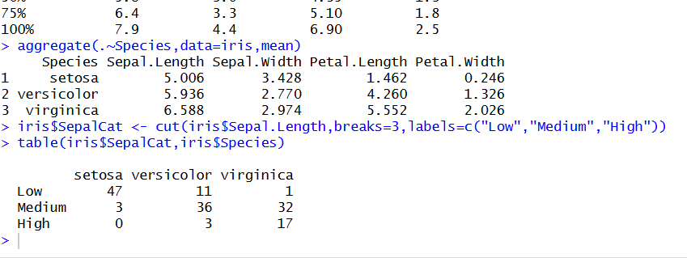
14. Explore and manipulate ChickWeight dataset (sorting, melting, casting by Diet).
PROGRAM:
data(USArrests)
summary(USArrests)
rownames(USArrests)[which.max(USArrests$Rape)]
max(USArrests$Murder)
min(USArrests$Murder)
cor(USArrests)
USArrests[USArrests$Assault>median(USArrests$Assault) & USArrests$Murder<quantile(USArrests$Murder,0.25),]
hist(USArrests$Murder)
plot(density(USArrests$Assault))
plot(USArrests$Murder,USArrests$Assault)
barplot(USArrests$Murder)

OUTPUT:
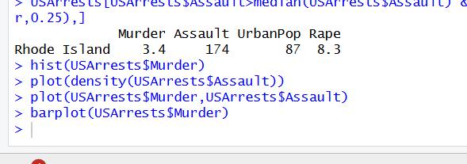
15. Perform EDA on iris dataset: dimensions, summary, standard deviation, quantiles, grouping by
PROGRAM:
data(iris)
dim(iris)
summary(iris)
sd(iris$Sepal.Length)
quantile(iris$Sepal.Length)
aggregate(. ~ Species, iris, mean)
# Category grouping
iris$Category <- ifelse(iris$Sepal.Length > 6, "High", "Low")
table(iris$Category)
OUTPUT:
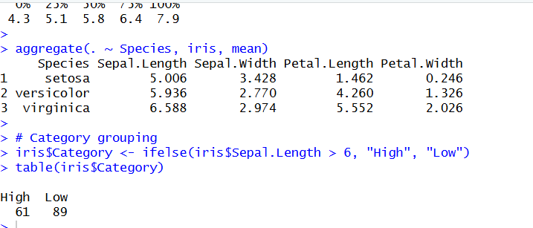

16.Explore USArrests dataset: summary statistics, state with largest rape arrests, max & min murder rates, correlation among features, states above median assault arrests and bottom 25% for murder, visualization with histogram, density, scatterplots, bar graphs.
PROGRAM:
# Load dataset
data(USArrests)

# Summary statistics
summary(USArrests)

# State with largest Rape arrests
rownames(USArrests)[which.max(USArrests$Rape)]

# Max & Min Murder rates
max(USArrests$Murder)
min(USArrests$Murder)

# Correlation among features
cor(USArrests)

# States above median Assault
median_assault <- median(USArrests$Assault)

USArrests[USArrests$Assault > median_assault, ]

# Bottom 25% Murder
q1 <- quantile(USArrests$Murder,0.25)

USArrests[USArrests$Murder <= q1, ]

# Histogram
hist(USArrests$Murder,
main="Histogram of Murder",
xlab="Murder Rate")

# Density plot
plot(density(USArrests$Murder),
main="Density Plot")

# Scatterplot
plot(USArrests$Murder,
USArrests$Assault,
main="Murder vs Assault",
xlab="Murder",
ylab="Assault")

# Bar graph
barplot(USArrests$Murder,
main="Murder Rates by State",
las=2)

OUTPUT:
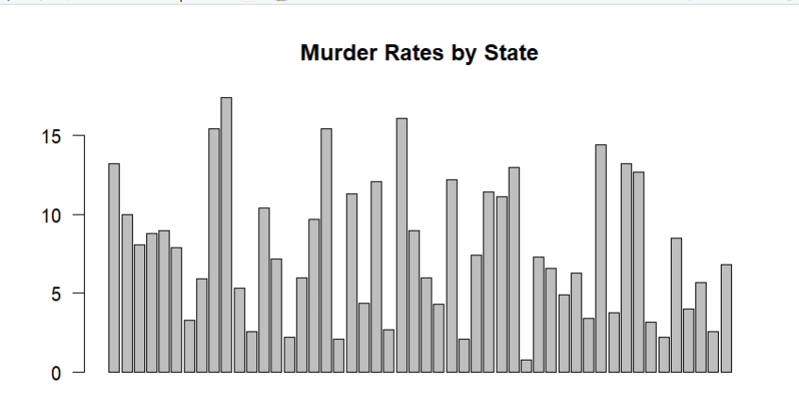

17. Explore Titanic dataset: bar chart of survival vs class, modify plot by gender, histogram of Age.
PROGRAM:
# Load dataset
data(Titanic)

titanic_df <- as.data.frame(Titanic)

# Survival vs Class
barplot(table(titanic_df$Survived,
titanic_df$Class),
beside=TRUE,
legend=TRUE,
main="Survival vs Class")

# Survival by Gender
barplot(table(titanic_df$Survived,
titanic_df$Sex),
beside=TRUE,
legend=TRUE,
main="Survival by Gender")

# Histogram of Age
hist(as.numeric(titanic_df$Freq),
main="Histogram of Age",
xlab="Age")

OUTPUT:
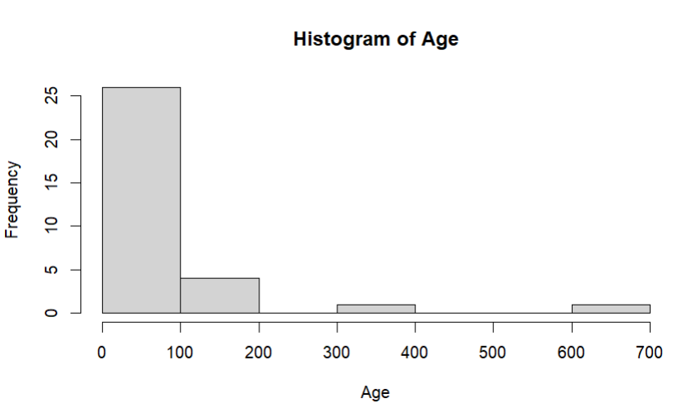

18. Create graphs in R: boxplot, histogram, bar plot, line chart, scatter plot.
PROGRAM:
data(iris)

# Boxplot
boxplot(iris$Sepal.Length,
main="Boxplot")

# Histogram
hist(iris$Sepal.Length,
main="Histogram")

# Bar Plot
barplot(table(iris$Species),
main="Bar Plot")

# Line Chart
plot(iris$Sepal.Length,
type="l",
main="Line Chart")

# Scatter Plot
plot(iris$Sepal.Length,
iris$Petal.Length,
main="Scatter Plot")
OUTPUT:
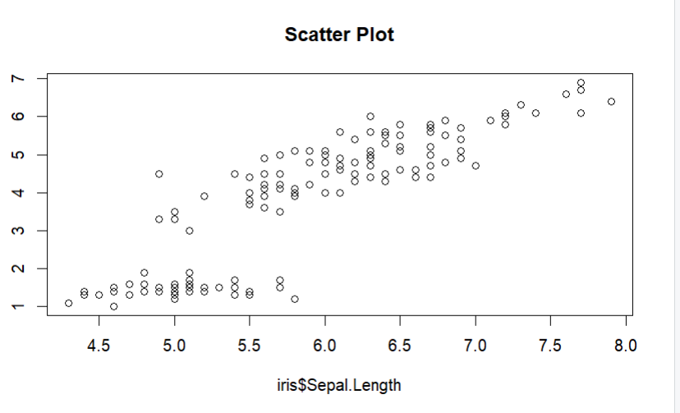
19. Build a regression model on advertising dataset (Sales ~ Spend) and predict Sales.
PROGRAM:
# Create dataset
advertising <- data.frame(
Spend=c(10,20,30,40,50),
Sales=c(12,25,35,45,55)
)

# Build model
model <- lm(Sales ~ Spend,
data=advertising)

summary(model)

# Predict Sales
predict(model,
data.frame(Spend=60))
OUTPUT:
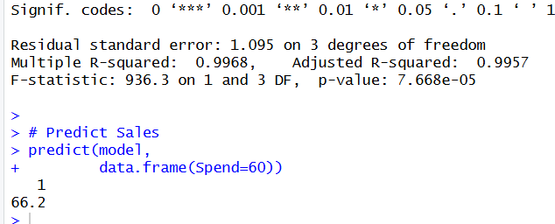
20. Create multiple regression model using ChickWeight dataset with “Time” and “Diet” as predictors; predict weight and compute model error.
PROGRAM:
data(ChickWeight)

# Convert Diet to numeric
ChickWeight$Diet <- as.numeric(ChickWeight$Diet)

# Model
model2 <- lm(weight ~ Time + Diet,
data=ChickWeight)

summary(model2)

# Prediction
pred <- predict(model2)

# Model Error (MSE)
mean((ChickWeight$weight - pred)^2)
OUTPUT:
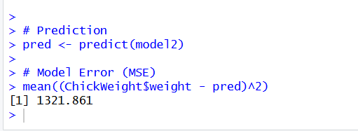
21. Randomly split iris dataset into train/test (80/20), build logistic regression (Species ~ Petal.Length + Petal.Width), predict, and evaluate with confusion matrix.
PROGRAM:
set.seed(1)

data(iris)

# Convert Species to binary
iris$Species <- ifelse(iris$Species=="setosa",1,0)

# Split 80-20
n <- nrow(iris)

index <- sample(1:n,0.8*n)

train <- iris[index,]
test <- iris[-index,]

# Model
model3 <- glm(Species ~ Petal.Length + Petal.Width,
data=train,
family=binomial)

# Prediction
prob <- predict(model3,
test,
type="response")

pred <- ifelse(prob>0.5,1,0)

# Confusion Matrix
table(Predicted=pred,
Actual=test$Species)
OUTPUT:
